USING YOUTUBE VIDEOS IN IMPROVING STUDENTS’ SPEAKING SKILLS

Bunga Putri Rahayu Sam
Pendidikan Bahasa Inggris, Universitas Muslim Indonesia bungaputrirahayu1@gmail.com

Syamsidar
Pendidikan Bahasa Inggris, Universitas Muslim Indonesia syamsidar.syamsidar@umi.ac.id

Irmawaty Hasyim
Pendidikan Bahasa Inggris, Universitas Muslim Indonesia irmawaty.hasyim46@gmail.com

Abstrak
Tujuan dari penelitian ini adalah untuk mengetahui keefektifan penggunaan video Youtube dalam meningkatkan keterampilan berbicara siswa dan permasalahan yang ditemukan siswa dalam menggunakan video Youtube untuk meningkatkan keterampilan berbicara siswa di Penelitian ini menggunakan metode kuantitatif dengan pendekatan eksperimen. penelitian dari hasil penelitian yang dilakukan selama 4 minggu dengan 8 kali pertemuan menunjukkan bahwa penggunaan video Youtube efektif dalam meningkatkan kemampuan berbicara siswa Hal ini terlihat dari nilai rata-rata post test yang lebih tinggi dari pada pre test ( 52,73 < 71,64 selain itu perhitungan statistik hipotesis dengan menggunakan uji sampel berpasangan menunjukkan nilai signifikan (2-tailed) adalah 0,00 < 0,05, hipotesis nol (HO) ditolak sedangkan hipotesis alternatif (H1) diterima yang artinya ada pengaruh yang signifikan penggunaan video Youtube melalui tanya jawab dalam teks prosedur pengajaran dan hasil dari Kuisioner menunjukkan bahwa tidak ada kendala atau masalah yang dirasakan siswa dengan menggunakan metode ini dapat dilihat dari persepsi terakhir "Saya memiliki beberapa masalah menggunakan media Youtube dalam proses pembelajaran" dan data melihat 40,90% siswa memilih tidak setuju, 36,36% ragu-ragu 18,18% setuju dan 4,54% sangat tidak setuju. Dari hasil angket ada beberapa siswa yang tidak cenderung bermasalah dalam menggunakan video Youtube dalam proses pembelajaran.

Kata Kunci : Keterampilan berbicara siswa, Teks prosesure, video Youtube

Abstract
The objectives of this research are to know the effectiveness of using YouTube videos to develop students' speaking skills through procedure text and To know the difficulties the students use YouTube videos to improve students speaking skills at .
This study used a quantitative method with approach pre-experimental research from the results of research conducted for 4 weeks with 8 meetings showed that using youtube videos effective in improving students' speaking skills This can be seen trom the post test average value which higher than the pre test (52.73 < 71.64) besides that the statistical calculation of the hypothesis by used paired sample test showed the value of significant (2-tailed) is 0.00 < 0.05, the null hypothesis (HO) was rejected where as the alternative hypothesis (H1) was accepted which means there is significant effect of using Youtube video through asked and answered quisionnaire in teaching procedure text and the results of this quisionnaire showed that there were no obstacles or problems that students feels by used this method it can be seen from the last perception "I have some problem used the youtube media in learning process" and the data saws 40.90% of students choose disagree, 36.36% undecided 18.18% agree and 4.54% strongly disagree. From the resulting questionnaire, some students didn't have a problem with using the YouTube video in the learning process.

Keywords: Speaking skills,Procedure text Youtube video

INTRODUCTION
Speaking is how to communicate the language itself. Muna (2011) states that speaking is oral communication in a two-way process between the speaker and listener which involves both the productive skill of speaking and the receptive skill of understanding (listening with understanding). To most people, speaking is the most difficult part of learning English. There are some factors of cause difficulties in speaking English, such as feeling bored with the media in the teaching and learning process, students need media that can attract their attention and provide comfort in learning to speak.
The researcher focuses on the learning process of the Procedural Text. The students in their daily lives practically need this kind of text. Types of Procedure Text discussed Recipe. The first Procedural text is the manual tip that was used as the material here. Based on the facts above, this study does research related to the effectiveness of using YouTube to improve the student's ability in speaking skills of Procedural Text.
YouTube videos can be interesting media that gives students better exposure and promising solutions to improve students’ English speaking skills. The researcher might choose this topic to investigate the potential benefits of using YouTube as a tool to enhance students' speaking skills due to its accessibility, engagement, and the opportunities it offers for authentic language learning.

METHOD
The researcher used a pre-experimental research method with a one-group pre-test-treatmentpost-test design. (Attawani and Romalioni, M. 2021) stated that pre-experimental research enables to researcher estimate the effect of pre-experimental research. There are independent variables and dependent variables independent variable is a material design taken from YouTube and the dependent variable of students' skill in speaking a procedure text. This research aims to know the effectiveness of using YouTube videos in improving students' speaking skills by asking and answering questions method with experimental research.
The population of this research was all of the students at Queen Makassar. The researcher chose this place of research because there is a condition that has to be increased. The researcher took all students from all classes using the proportional sample technique, the researcher determined the number of samples is 22 students from one class. It is considered as the representative of the whole population from one class and as the representative from each class.
Speaking test, this test is to obtain data related to “How effective is the using of YouTube videos in improving students’ speaking skill through procedure text at Queen Institute” The test would consist of a pre-test and a post-test. In the pre-test, the students would be given three pictures and students would choose one of three pictures that they took and then they would speak up orally in front of the class. In the post-test, they looked for something new about procedure text that they explained in the first of the class. The process of the test took around 40 minutes.
The questionnaire aims to find out students' difficulties that are their problems found in using YouTube videos to improve their speaking skills.
The data of the research on the effectiveness of using YouTube videos in improving students' speaking skills was obtained, the data obtained from the speaking test was analyzed by using paired test analysis through the SPSS program statistics, and the data that was obtained from the questionnaire was b analyzed qualitatively. All the data would be explained deeply.

FINDINGS
This chapter deals with the presentation of the data analysis as well as the discussion on the result of the data analysis. There were two kinds of instruments used in this research to collect the data, namely: a speaking test and a questionnaire. The part showed the general description of the student's scores in both the pre-test and post-test. The findings of the research consist of the description of the result from the data collected through the test (pre-test and post-test). The discussion is the description of the findings that have been analyzed by the SPSS program statistics. The research also collected data by questionnaire to find out students’ problems in using YouTube videos to improve speaking skills.

Table 1. The Pre-Test Score

No | Name | Pronunciation | Grammar | Vocabulary | Fluency | Comprehension | Score
1 | Participant 1 | 3 | 3 | 3 | 3 | 3 | 60
2 | Participant 2 | 2 | 2 | 3 | 2 | 3 | 48
3 | Participant 3 | 2 | 2 | 2 | 3 | 2 | 44
4 | Participant 4 | 2 | 2 | 2 | 2 | 2 | 40
5 | Participant 5 | 3 | 4 | 4 | 3 | 3 | 68
6 | Participant 6 | 4 | 3 | 3 | 3 | 3 | 64
7 | Participant 7 | 3 | 3 | 2 | 3 | 3 | 56
8 | Participant 8 | 3 | 2 | 3 | 3 | 3 | 56
9 | Participant 9 | 3 | 2 | 2 | 3 | 3 | 52
10 | Participant 10 | 3 | 3 | 3 | 3 | 3 | 60
11 | Participant 11 | 2 | 2 | 2 | 3 | 2 | 44
12 | Participant 12 | 3 | 3 | 3 | 3 | 3 | 60
13 | Participant 13 | 2 | 2 | 2 | 2 | 2 | 40
14 | Participant 14 | 3 | 2 | 3 | 3 | 3 | 56
15 | Participant 15 | 3 | 3 | 3 | 2 | 2 | 52
16 | Participant 16 | 3 | 2 | 3 | 3 | 3 | 56
17 | Participant 17 | 3 | 2 | 3 | 3 | 3 | 56
18 | Participant 18 | 2 | 2 | 2 | 3 | 3 | 48
19 | Participant 19 | 2 | 2 | 2 | 3 | 2 | 44
20 | Participant 20 | 3 | 3 | 3 | 3 | 3 | 60
21 | Participant 21 | 3 | 2 | 3 | 3 | 4 | 60
22 | Participant 22 | 2 | 1 | 2 | 2 | 2 | 36
The data shows that the highest of students on the pre-test was 68 with fairly correct grammar and vocabulary and then the lowest score was 36 with very poor grammar.
Table 2. The Post-test Score

No | Name | Pronunciation | Grammar | Vocabulary | Fluency | Comprehension | Score
1 | Participant 1 | 4 | 4 | 4 | 3 | 3 | 72
2 | Participant 2 | 3 | 4 | 4 | 3 | 3 | 68
3 | Participant 3 | 3 | 3 | 4 | 4 | 4 | 72
4 | Participant 4 | 3 | 3 | 3 | 3 | 4 | 64
5 | Participant 5 | 4 | 4 | 4 | 4 | 4 | 80
6 | Participant 6 | 4 | 3 | 4 | 4 | 4 | 76
7 | Participant 7 | 4 | 3 | 3 | 4 | 4 | 72
8 | Participant 8 | 4 | 3 | 3 | 4 | 4 | 72
9 | Participant 9 | 4 | 3 | 4 | 4 | 4 | 76
10 | Participant 10 | 4 | 4 | 4 | 4 | 4 | 80
11 | Participant 11 | 3 | 3 | 3 | 4 | 4 | 68
12 | Participant 12 | 4 | 3 | 4 | 4 | 4 | 76
13 | Participant 13 | 4 | 3 | 3 | 3 | 4 | 68
14 | Participant 14 | 3 | 3 | 4 | 4 | 4 | 72
15 | Participant 15 | 4 | 3 | 4 | 3 | 4 | 72
16 | Participant 16 | 4 | 3 | 3 | 4 | 4 | 72
17 | Participant 17 | 4 | 3 | 4 | 4 | 4 | 76
18 | Participant 18 | 3 | 3 | 3 | 4 | 3 | 64
19 | Participant 19 | 3 | 3 | 3 | 3 | 3 | 60
20 | Participant 20 | 4 | 3 | 4 | 4 | 4 | 76
21 | Participant 21 | 4 | 4 | 4 | 4 | 4 | 80
22 | Participant 22 | 3 | 2 | 3 | 3 | 4 | 60
After getting treatment, post-test data showed that 3 students got the highest score of 80 with improved speaking ability, then 2 people got the lowest score of 60 with an ability that was quite improved but needed to be improved again.

Table 3. Student Development Score
No | Name | Pre-test Score | Post-test Score
1 | Participant 1 | 60 | 72
2 | Participant 2 | 48 | 68
3 | Participant 3 | 44 | 72
4 | Participant 4 | 40 | 64
5 | Participant 5 | 68 | 80
6 | Participant 6 | 64 | 76
7 | Participant 7 | 56 | 72
8 | Participant 8 | 56 | 72
9 | Participant 9 | 52 | 76
10 | Participant 10 | 60 | 80
11 | Participant 11 | 44 | 68
12 | Participant 12 | 60 | 76
13 | Participant 13 | 40 | 68
14 | Participant 14 | 56 | 72
15 | Participant 15 | 52 | 72
16 | Participant 16 | 56 | 72
17 | Participant 17 | 56 | 76
18 | Participant 18 | 48 | 64
19 | Participant 19 | 44 | 60
20 | Participant 20 | 60 | 76
21 | Participant 21 | 60 | 80
22 | Participant 22 | 36 | 60
Mean |  | 52.73 | 71.64
The table shows the mean scores pre-test and post-test, it can be seen that there was an improvement in the mean after being given treatment from the pre-test 52.73 to the post-test 71.64, increased by 35.86% it can be concluded that the method using a YouTube video is effective in improving speaking skills students at Queen Institute.

Table 4. The Students’Level at Queen Institute
Score | Level | Pre-test | Post-test
9,6 – 10 | Excellent | - | -
8,6 – 9,5 | Very Good | - | -
7,6 – 8,5 | Good | - | 8
6,6 – 7,5 | Fairly Good | 1 | 14
5,6 – 6,5 | Fair | 11 | -
3,6 – 5,5 | Poor | 10 | -
The result of students' level on the pre-test and post-test, the result of the data analysis set as a pre-experimental finding showed the effectiveness of the word mapping game to improve the student's vocabulary mastery.

Table 5. Normality Test

 | Kolmogorov-Smirnovª |  |  | Shapiro-Wilk
 | Statistic | Df | Sig. | Statistic | df |  | Sig.
Pre | .194 | 22 | .031* | .948 |  | 22 | .288
Post | .206 | 22 | .016 | .922 |  | 22 | .084
Based on the output table “tests of Normality” in the Shapiro Wilk test section, it is known that the value of significant for the pre-test value of 288 and the post-test value of 084. Because the value is greater than 0.05, it can be concluded that the pre-test and post-test data values are normally distributed.
Table 6. Paired samples Test

 |  |  |  | Paired Differences |  |  | t | df | Sig. (2-tailed)
 |  | Mean | Std. Deviation | Std. Error  Mean | 95% Confidence Interval of the  Difference |  | t | df | Sig. (2-tailed)
 |  |  |  |  | Lower | Upper | t | df | Sig. (2-tailed)
Pair 1 | pre-post | -18.909 | 4.810 | 1.025 | -21.042 | -16.777 | -18.440 | 21 | .000
Based on the “Paired Samples Test” output table above, it is known that the value of significant (2-tailed) is 0.00 < 0.05, then H0 is rejected and Ha is accepted. So it can be concluded that there is an average difference between the pre-test and post-test learning outcomes, which means there is a significant effect of using YouTube videos through asking and answering questions in teaching procedure text.

Table 7. Using YouTube Media Can Help Me to Understand the Lesson Easily

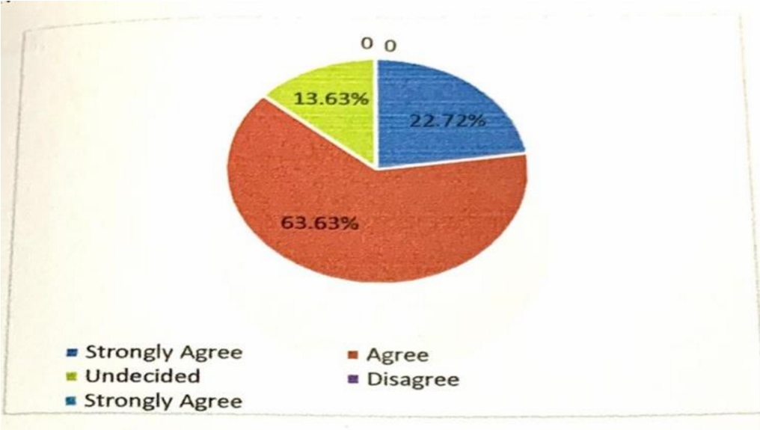
The data shows that 22.72% of students chose strongly agreed, 63.63%, agree and 13.63% were undecided. This means that the use of Youtube media can help them to understand the lesson easily.

Table 8. Use the YouTube Media Effective to Improve Student Interest in English Learning.
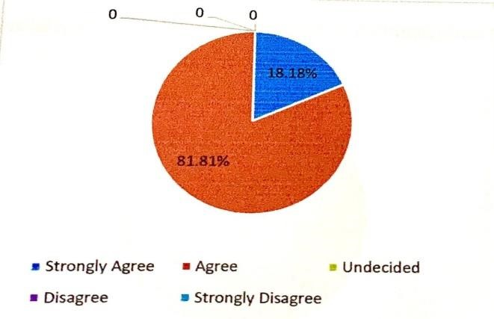
The data shows that 18.18% of students chose strongly agreed, and 18.81% agreed. This means that YouTube media is effective in improving students' interest in English learning.
Table 9. The study by using Youtube Media Can Effectively Improve Students Speaking Skills.
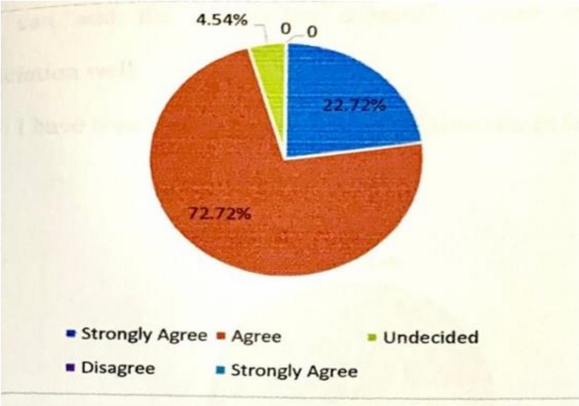

The data shows that 22.72% of students chose strongly agreed, 72.72% agreed, and 4.54% undecided. It means studying by using YouTube media can effectively improve students' speaking skills.
Table 10. Learning English by Using YouTube Media and Adding Knowledge, Especially About Vocabulary and English Pronunciation.
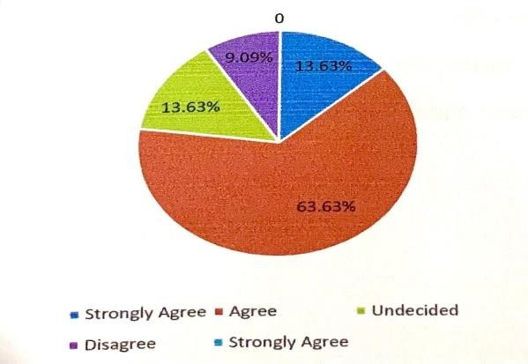
The data shows that 13.63% of students strongly agreed, 63.63% agree 13.63% undecided. and 9.09% disagree. So learning English by using YouTube media can add knowledge, especially about vocabulary and English pronunciation well.
Table 11. I Have Some Problems Using Youtube Media in the Learning Process

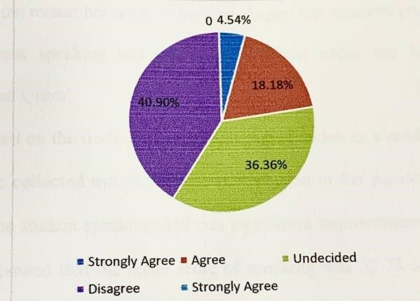
Finally, in the fifth graph, the data saws 40.90% of students choose to disagree, 36.36% undecided 18.18% agree. and 4.54% strongly disagree. From the resulting questionnaire, there were some students who didn't tend the problems using YouTube videos in the learning process.

DISCUSSION
Based on the findings of applying YouTube videos as a media in the class, the data collected through the test as explained in the previous finding section showed the students' speaking skills were significantly improved. The data on the table pre-test showed that the mean score of speaking was 52.73 and on the post-test table was 71.64. After calculating the score, the researcher found that the students' speaking skills improved (35.86%) from the means score in the pre-test to the post-test it was supported by the means score post-test of students speaking skills was higher than the pre-test.
The score of the student's post-test was higher than the mean score of the student's pre-test. Therefore, YouTube videos were effective in improving students' speaking skills in terms of true procedure text. (Almurashi, 2016) also stated that YouTube can be a good material to incorporate English lessons, improve their performance, play a vital role in helping pupils understand their English lessons, and can also advance their understanding of English. In addition, (Albahlal, 2019that) states that YouTube videos help students guess the meaning of unfamiliar words and improve their speaking skills and also lower the students' anxiety, help students learn faster, and retain the students' attention during class.
The researcher found that based on the paired sample test output table above, it is now that the value of significance (2-tailed) is 0.00 < 0.05. this means that the researcher concluded that YouTube videos were effective in improving students' speaking skills. Through procedure text. From the discussion above, it can be concluded that the students' speaking skills at students of Queen Institute can be improved in speaking skill by using YouTube videos through procedure text.
The researcher has analyzed the results of the research data collection. For this part, the researcher analyzed students' problems with the use of YouTube videos to improve students' speaking skills. Data were obtained from questionnaires distributed to students. 10 students filled out the questionnaire to answer the second question. there were five main points in the study of students' perceptions of the used YouTube videos in improving speaking skills.
The first issue is that YouTube media can help me to understand the lesson easily. Using YouTube media is more helpful for students in learning to provide many new ideas that can improve students' speaking skills, the data shows 22.72% of students strongly agreed, 63.63% agreed and 13.63% were undecided. This means that the use of YouTube media can help them to understand the lesson easily. So the researcher suggests teachers apply the method of using YouTube media to help improve students' speaking skills and become an effective method used in learning for students.
Second, Use YouTube media effectively to improve student interest in English learning. The data shows that using YouTube media is effective in increasing student interest in learning English in general in practicing speaking. From the data saws, 18.18% of students strongly agreed, and 18.81% agreed. This means that the use of YouTube media is effective in improving students' interest in English learning. So the researcher assumed this method is good to apply in learning English.
Third, a Study using YouTube media can effectively improve students' speaking skills. Learning to use YouTube media affects students' speaking skills because with this method students get more ideas and input to improve students speaking skills. From the data saws 22.72% of students chose strongly agreed,72.72% agreed, and 4.54% undecided. It means studying by using YouTube media can effectively improve students' speaking skills. So the researcher recommends the method of using YouTube media to improve students' speaking skills.
Fourth, Learning English by using YouTube media can add knowledge, especially about vocabulary and English pronunciation. From the data saws, 13.63% of students strongly agreed, 63.63% agree13.63% were undecided, and 9.09% disagreed. So learning English by using YouTube media can add knowledge, especially about vocabulary and English pronunciation well. So the researcher thinks this method of using YouTube videos is good for students to use in improving speaking skills because it can increase students' vocabulary and pronunciation. Fifth, I have some problems using YouTube media in the learning process. The data shows that 40.90% of students choose to disagree, 36.36% are undecided 18.18% agree and 4.54% strongly disagree. From the results questionnaire some students didn’t have a problem with using YouTube videos in the learning process, from the data shows that the dominant student chose to disagree, which means that they do not have a problem using YouTube video media in the learning process. Finally, Student questionnaire data proves that the use of the YouTube video method is very effective in improving students' speaking skills, there are no problems that students find in the application of YouTube video. Students like this method which means that this method is successful in improving students' speaking skills.

CONCLUSION
YouTube videos were effective in improving the students' speaking skills. It was proven by the students speaking skill achievement in the post-test was greater than in the pre-test (52.73 < 71.64) and the improvement of the students' speaking skills was (35.86%). It can be concluded that the students' speaking skills improved after applying YouTube videos through procedure text.
Based on the result of the questionnaire the researcher found using YouTube videos to improve students speaking skills. There or five main points in the study of students' perception in the use of using YouTube videos on their student speaking skills that make it effective for students to understand the material (procedure text) increase their knowledge about the material and motivate the students to improve students speaking skills. Student data questionnaire proves that the use of the YouTube video method was effective in improving students' speaking skills, most students do not find problems in implementing the use of YouTube videos, however, some students find problems such as this YouTube video consuming too much internet quota then sometimes this YouTube video playback is often loading because the network is not supported.

REFERENCES
Lar, Maulidya Amhar Amin, and Maulina Maulina. "Students’self-Confidence in Speaking for A Live Presentation: A Literature Review." Klasikal: Journal of Education, Language Teaching and Science 3.3 (2021): 88-95.
Muna, Muhammad Sirrul. "Utilizing YouTube Videos to Enhance Students’ Speaking Skill." (2011).
Meinawati, Euis, R. N. A., Harmoko, Danang Dwi, & Dewi, N. (2020). Increasing English Speaking Skills Through Youtube. Jurnal Ilmiah, 16, 1-13.
Attawani, & Romalioni, M. (2021); Indonesian Joumal of Primary Education. C 2021- "Indonesian Journal of Primary Education, 5(1), 1-12.
Almurashi, W. A. (2016). The effective use of YouTube videos for teaching English language in classrooms as supplementary material at Taibah University in Alula. International Journal of English Language and Linguistics Research, 4(3), 32-47.
Albahlal, Fahad Saud. "The Impact of YouTube on Improving Secondary School Studentsâ€™ Speaking Skills: English Language Teachersâ€™ Perspectives." Journal of Applied Linguistics and Language Research 6, no. 2 (2019): 1-17.

