AN ERROR ANALYSIS IN TRANSLATING ENGLISH NARRATIVE TEXT INTO INDONESIAN THROUGH GOOGLE TRANSLATE APPLICATION

Nurul Amalia
Pendidikan Bahasa Inggris, Universitas Muslim Indonesia
nurulamaliayusuf1108@gmail.com

Muhammad Yunus
Pendidikan Bahasa Inggris, Universitas Muslim Indonesia
muhammad.yunus@umi.ac.id

Muhajir
Pendidikan Bahasa Inggris, Universitas Muslim Indonesia
muhajir.sastra@umi.ac.id

Abstrak
Penelitian ini bertujuan untuk menyelidiki kesalahan gramatikal yang paling umum dilakukan dengan menggunakan Google Translate dalam menerjemahkan teks naratif dan untuk mengeksplorasi persepsi siswa dalam menerjemahkan dalam teks naratif menggunakan google translate semester pertama pendidikan bahasa Inggris di Universitas Muslim Indonesia. Metode penelitian adalah metode kualitatif yang dilakukan pada program studi Pendidikan Bahasa Inggris Semester pertama Universitas Muslim Indonesia. Total sampel adalah 12 siswa. Instrumen penelitian yang digunakan adalah grammar test dan angket. Data dianalisis berdasarkan jenis kesalahan yang dibuat oleh siswa. Beberapa jenis kesalahan yang dilakukan oleh siswa dalam menggunakan google translate. Kesalahan-kesalahan itu adalah yaitu omission, misformation, misformation dan addition.

Kata Kunci: Google Translate, Teks narasi, perspektif

Abstract
This research aims to To investigate the most common grammatical errors made by using Google Translate in translating narrative text and to explore the students’ perception in translating in narrative text using google translate first semester of english education at Universitas Muslim Indonesia. The research method is qualitative method conducted at the first Semester English Education study program at Universitas Muslim Indonesia. The total sample were 12 students. The research instrument employed were grammar test and questionnaire. The data were analysed based on the type of error made by students. some types of error made by student in using google translate. Those errors were of omission,misformation, misordering and addiction

Keywords: Translation, Narrative text, perspection

INTRODUCTION
In learning English, sometimes students do not know what it means when they are working on a text and often make mistakes, especially narrative texts. This where because students' understanding of translation was still lacking, therefore lessons on translating texts must need to be taught to students so that students can translate well so that they no longer make mistakes, especially when translating narrative texts. Sometimes students can only translate word by word, But, if they translate one text the students cannot, so this makes students' knowledge not increase. Which makes students unable to translate well because students' vocabulary is reduced (Narulita S, 2016). In doing the task of translating narrative text, students still often make mistakes they often ignore important things in translating the text. Students sometimes make mistakes with several mistakes in between, omitting a word or two words, adding or more items in speech, and omitting punctuation marks. So that the meaning of student translation results changes (Istiqomah, 2016). the translation using Google Translate is not the right solution for someone who wants to translate foreign language text (Anggaira,2017).
The text used to see the students’ errors in translating English sentences into Indonesian in narrative was a text entitled: The little shepherd boy & wolf. Translation material of an Eng-lish narrative text took from the source: Fabel (Cerita Rakyat) Bahasa Inggris. The narrative text contained four paragraphs, and consisted from 316 words, and 24 sentences. The reason why the researcher chose this title as the title of the study was because the researcher wanted to see the results of students' narrative text translations and students' mistakes in translating narrative text. By considering the problems discussed above, translating has an important role to make students' English comprehension increase
This research aims to investigate the most common grammatical errors made by using Google Translate in translating narrative text and to explore the students’ perception in translating in narrative text using google translate first semester of English Education at Universitas Muslim Indonesia. The research method is qualitative method conducted at the first Semester English Education study program at Universitas Muslim Indonesia through grammar test and questionnaires. The results of student translations are identified and classified by type and source of error to make it easier for readers to understand the data.

METHOD
This study employed a qualitative research method To investigate the most common grammatical errors made by using Google Translate in translating narrative text and To explore the students’ perception in translating in narrative text using google translate of the first semester of english education at Universitas Muslim Indonesia. The research was conducted at the first semester of English Education at Universitas Muslim Indonesia. The choice of this research site was based on its accessibility and the presence of the identified problem related to students'. The data source consisted of 12 students. The students' ages ranged from 19 to 20 years, with a gender distribution of 2 boys and 10 girls.

FINDINGS

The Most Common Grammatical Errors Made by Using Google Translate in Translating Narrative Text (tambahkan tempat penelitian)
The researcher classified the errors into the types of errors. The students’ writing was identified and classified based on types of errors according to Dullay et al (1982). The response of the students about the most common grammatical errors made by using google translate in translating narrative text found by using a grammar test. The grammar test results can be seen in the following table.

Table 1. Students’ Error in Omission
No | Errors | Suggested
1 | He had to send the sheep out to pasture and watch over them as they grazed | He had to send the sheep out to pasture and watched over them as they grazed
2 | Came running with tones to chase … | Came running with stones to chase …
3 | The boy, laughed at the fear he caused | The boy, laughed at the fear he had caused
Based on the sentence above it concluded he students sometimes forgot of using tobe(was,were) and used past simple on the sentence.

Table 2. Students’ Error in Miss Information
No. | Errors | Suggested
1 | He shouted, “ Wolves,wolves!... | He shouted, “ Wolf,wolf!...
2 | He wants to run and play… | He wanted to run and play…
3 | The thre day, when the boy climbed…. | The third day, when the boy climbed….
Based on the sentence above it can concluded that was the students could not make it different of using past and present.

Table 3. Students’ Error in addition
No. | Errors | Suggested
1 | … that he was old enough 2. | … that he was old enough
2 | Does not he look at the sheep | Not look at the sheep
Based on the sentence above the students are too dependent with the google translate even the sentence was not make sense.

Table 4. Students’ Error in Misordering
No. | Errors | Suggested
1. | In a village, carefree boy there lived with his father | In a village, there lived a carefree boy with his father
Based on the sentence above there was students did not understand the sentence.
Based on the analysis above, it can be concluded that the first type of error is done by the students is omission where students make a mistake when leaving out an item that is required, that is with error frequency amount to 30 with 24% percentages. The second type of error is addition where the students had errors with Characterized by the presence, with error frequency amount to 4 with 4% percentages. The third type of error is missformation where the students make an error when using grammatical form in place of another grammatical, with error frequency amount to 98 with 71% percentage. And the last one is the fourth type of error is missordering, where students make errors when putting the words in an utterance in the wrong order, with error frequency amount to 1 with 1%. Based on the analysis above, most of the errors done by English Education students is missformation.

The students’ perceptions in translating narrative text using google translate
The response of the students about The students’ perceptions in translating narrative text using google translate was found by using a questionnaire, a set of questionnaires consisting of 15 questions. The questionnaire results can be seen in the following table.
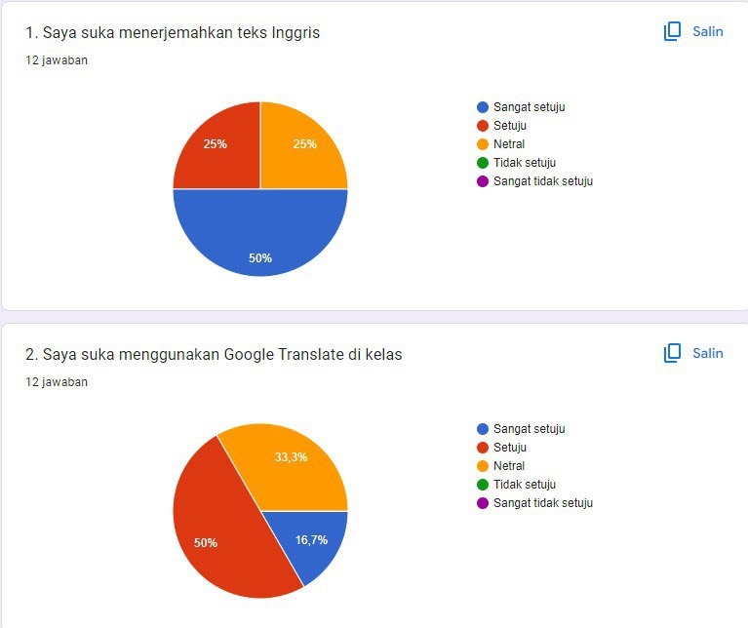

Figure 1. Students’ like to translate English
Figure 1 showed that the graph above that 50% of the students strongly agree, 25% of the students agree and neutral. It could be concluded that students had a like more to translate English.

Figure 2. Students’ like in using google translate in the class
Figure 2 showed that the graph above that 16,7% of the students strongly agree, 50% of the students agree and 33,3% of students neutral. It could be concluded that students prefered using google translate in the class.

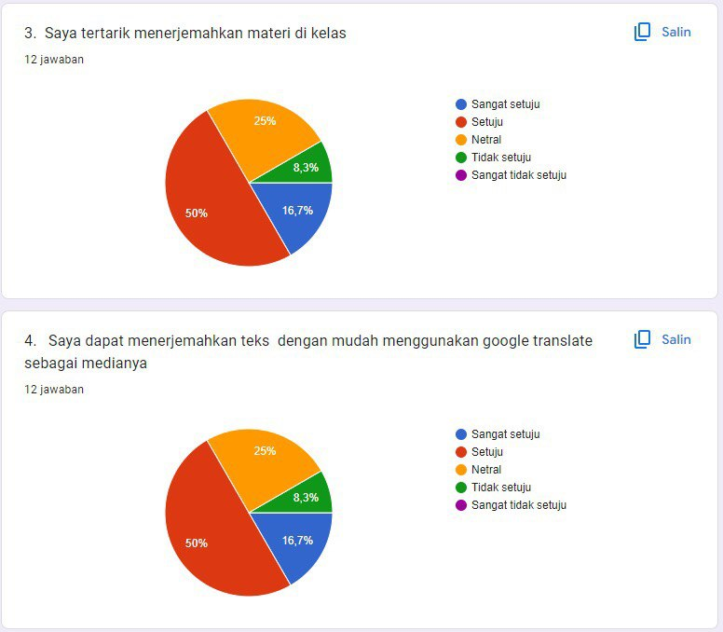

Graph 3 Students’ interest to translate lesson in the class
Graph 3 showed that the graph above that 16,7% of the students strongly agree, 50% of the students agree, 25% of students neutral and 8,3% of students Disagree. It could be concluded that students interested to translate lesson in the class.

Figue 4. The benefits of google translate for students to translate
Figure 5 showed that on the graph above that 16,7% of the students strongly agree, 50% of the students agree, 25% of students neutral and 8,3% of students Disagree. It could be concluded that students got the benefits of google translate.

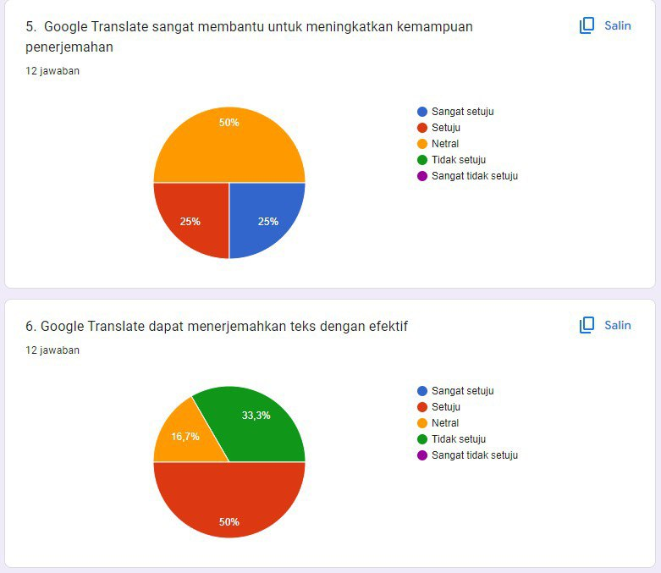

Figure 5. The function of google translate to improve translation ability
Figure 5 showed that on the graph above that 25% of the students strongly agree and agree, and 50% of students neutral. It could be concluded that students did not improve translation ability of google translate.

Figure 6. The effectiveness of google translate to translate the text
The graph showed that 50% of the students agree, 16,7% of students neutral and 33,3% of students disagree. It could be concluded google translate was effective for students.

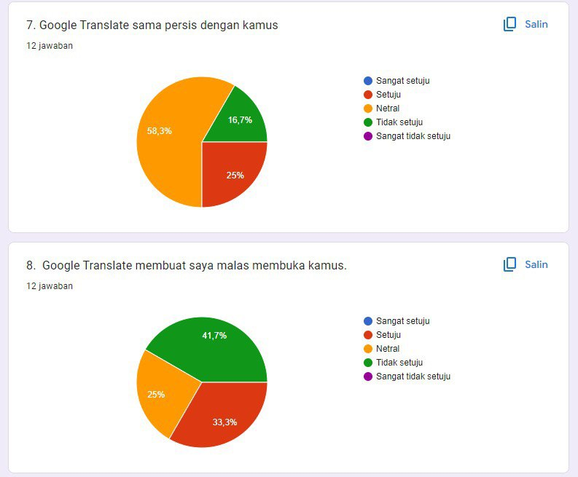
Figure 7. The google translate is similar with dictionary
Figure shows that of 25% of the students strongly agree and agree, and 50% of students neutral. It could be concluded that students did not improve translation ability of google translate

Figure 8 Google translate made students were lazy
Figure shows that of 33,3% of the students agree, 25%% of students neutral and 41% of students disagree. It could be concluded that students did not felt google translate make students were lazy.
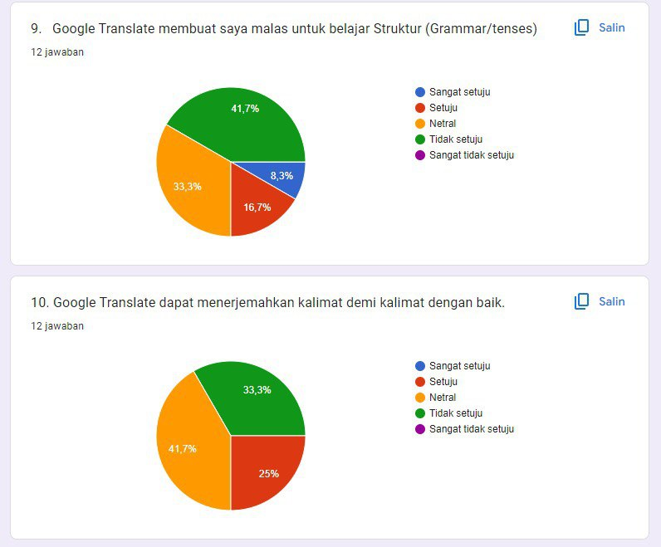

Figure 9. Google translate made students were lazy to studied grammar/tenses
The figure showed that 8,3% of the students strongly agree, 16,7% of the students agree, 33,3% of students neutral and 41,7% of students disagree. It could be concluded that used Google translate did not make students were lazy to studied grammar/tenses.

Figure 10. Google translate was able to translate with the good sentence
The figure showed that 25% of the students agree, 41,7% of the students neutral and 33,3% of students disagree. It could be concluded that some of students Google translate was able to translate with the good sentence.
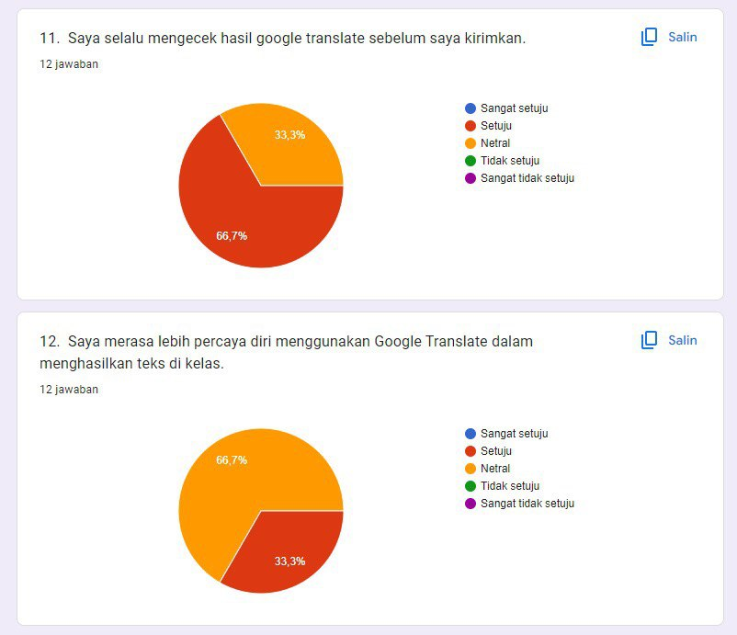

Figure 11. The students always checked the result of google translate before they sent it.
The graph showed that 66,7% of the students agree, and 33,3% of students neutral. It could be concluded that the students always checked the result of google translate before they sent it.

Figure 12. The students felt more confidence to used google translate in the class
The graph showed that 33,3% of the students agree, and 66,7% of students neutral. It could be concluded that some of students felt more confidence to used google translate in the class

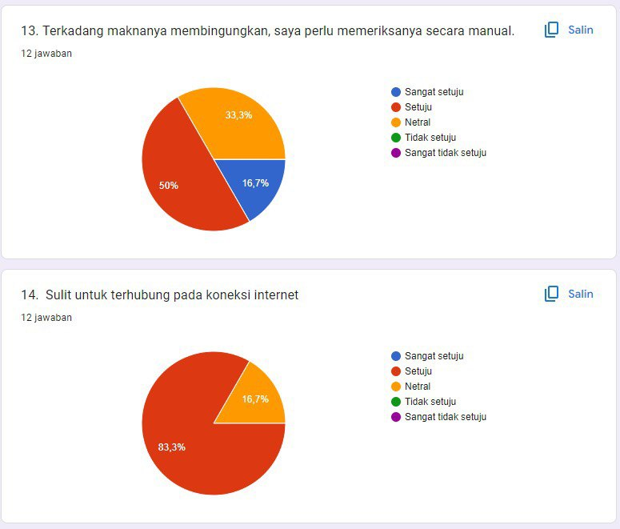

Figure 13. The students were confused, so they have to rechecked manually
The graph showed that 16,7% of the students strongly agree, 50% of students agree and 33,3% of students neutral. It could be concluded that students have to recheck manually.

Figure 14. The students were confused, so they have to rechecked manually
The graph showed that 83,3% of the students agree, and 16,7% of students neutral. It could be concluded that students were difficult connection internet.

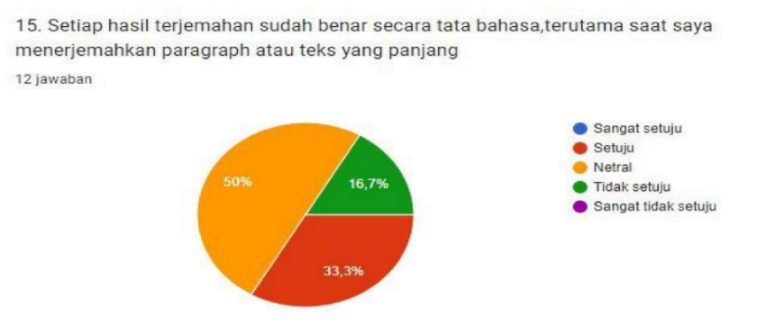

Figure 15. The sentence is correct as structural to translated paragraph
The graph showed that 33,3% of the students agree, 50% of students neutral and 16,7 of students disagree. It could be concluded that some of students felt the sentence is correct as structural to translated paragraph in the class.

DISCUSSION

The most common grammatical errors made by using google translate in translating narrative text on the first semester of English Education of Universitas Muslim Indonesia
The aims of this research are to classify type of errors are made by the first Semester students of English Education Department of Faculty of Letter of Universitas Muslim Indonesia in using Google translation and to know Perceptions by the first Semester students of English Education study program of Faculty of Letter of Universitas Muslim Indonesia ability in using Google translation.
Based on the analysis above, it can be concluded that the first type of error is done by the students is omission where students make a mistake when leaving out an item that is required, that is with error frequency amount to 30 with 24% percentages. The second type of error is addition where the students had errors with Characterized by the presence, with error frequency amount to 4 with 4% percentages. The third type of error is misformation where the students make an error when using grammatical form in place of another grammatical, with error frequency amount to 98 with 71% percentage. And the last one is the fourth type of error is misordering, where students make errors when putting the words in an utterance in the wrong order, with error frequency amount to 1 with 1%.
Based on the analysis above, most of the errors done by English Education students is misformation. Because most the First Semester Students of English Education Department of Faculty of Letter of Universitas Muslim Indonesia seldom used google translation.

The students’ perceptions in translating narrative text using google translate on the first semester of English education at Universitas Muslim Indonesia.

The perpections by the the First Semester students of English Education Study Program of Faculty of Letter of Universitas Muslim Indonesia in using google translation. the students perceptions of the students such as, they interested in using google translation, google translation is effective for students, and they felt easier to used google translate. That was some of perceptions by the the First Semester students of English Education Department of Faculty of Letter of Universitas Muslim Indonesia ability in using Google translate.

CONCLUSION
The results that were analyzed can be concluded that the results grammar test concluded that The first mistake made by the First Semester Students of English education Department of Faculty of Letter of Universitas Muslim Indonesia students is omission where students make a mistake by change the word.The questionnaire, almost all the students answered agree to preferred using google translate in the class and feel interest to translate. But, some of students were difficult connect to connection internet.

REFERENCES
Narulita, S. (2016). Error Analysis on Students Narrative Text in Translation Class of English Department of Kutai Karta Negara University. Jurnal Intelegensia. 13-29.
Istiqomah, N. (2016). The Analysis of Students Problem in Translating Narrative Text Into Indonesian At The Eight Grade of Smp N 4 Purwerejo. 1-163.
Anggaira, A, S. (2017). Problems in the Application of Google Translate As a Learning Media in Translation. Language Literacy: Journal of Linguistics, Literature, and Language Teaching, 4(2).
Heidi, D. (1982). Language Two. New York: Oxford University Press.
Josefsson, E. (2011). Contemporary Approaches to Translation in the Classroom: A study of students’ Attitudes and Strategies, 1-32. on January 20th 2019.
Borodina, M., Golubeva, T. I., Korotaeva, I. E., Shumakova, S. Y., Bessonova, T. V., & Zharov, A. N. (2021). Impact of the Google translate machine translation system on the quality of training student translators. Technology.
Al Farisi, M. Z., Tantowi, Y. A., & Nurmala, M. (2023). Language, Culture, and
Translation. Prosiding Pertemuan Ilmiah Internasional Bahasa Arab, 14(1), 1093–1102.
Sugiyono. (2014). Statistika Untuk Penelitian. Bandung: Alfabeta.

