THE USING OF SPELLING BEE GAMES IN IMPROVING THE STUDENTS’ READING SKILL

Nur Hunaisya
uncho.nurhunaisya@gmail.com
Universitas Muslim Indonesia

Muhajir
muhajir.sastra@umi.ac.id
Universitas Muslim Indonesia

Rizkariani Sulaiman
rizka.sulaiman@umi.ac.id
Universitas Muslim Indonesia

Abstrak: Nur Hunaisya. 2024. Penggunaan Permainan Spelling Bee dalam Meningkatkan Keterampilan Membaca Siswa. (Dibimbing oleh Muhajir, S.S., M.Pd., Ph.D. dan Rizkariai Sulaiman, S.Pd., M.Pd.) .Penelitian ini bertujuan untuk menyelidiki efektivitas permainan ini dalam meningkatkan keterampilan membaca siswa. Penelitian ini menggunakan pendekatan kualitatif. Temuan menunjukkan kontribusi positif permainan Spelling Bee dalam meningkatkan keterampilan membaca siswa kelas sembilan. Hasil dari wawancara dan kuesioner mengungkap kesepakatan di antara siswa mengenai manfaat permainan tersebut. Sampel penelitian terdiri dari 31 siswa dari kelas IX-7. Penelitian ini menekankan pentingnya mengintegrasikan kegiatan pendidikan interaktif untuk pengembangan keterampilan membaca siswa. Sebagai kesimpulan, permainan Spelling Bee muncul sebagai alat yang berharga untuk meningkatkan kemampuan membaca siswa dan membentuk lingkungan belajar yang dinamis dan bermakna.

Kata Kunci: Permainan, Mengeja, Keterampilan Membaca

Abstract: Nur Hunaisya. 2024. The Using of Spelling Bee Games in Improving the Students' Reading Skill. (Supervised by Muhajir and Rizkariai Sulaiman) This research aims is to investigate the using of Spelling bee games in improving the students' reading skills. The research employs a qualitative approach. Findings indicate a positive contribution of the Spelling Bee game to the enhancement of ninth-grade students' reading skills. Results from interviews and questionnaires reveal a consensus among students regarding the benefits of the game. The research sample consists of 31 students from grade IX-7 at SMP Negeri 23 Makassar. The study underscores the importance of integrating interactive educational activities for the development of students' reading skills. In conclusion, the Spelling Bee game emerges as a valuable tool for improving students' reading proficiency and fostering a dynamic and meaningful learning environment.

Keywords: Games, Spelling, Reading Skill

INTRODUCTION
Indonesian students often face challenges in reading English words due to English being a foreign language to them and differing from their native language, Bahasa Indonesia. Many students struggle to comprehend English words, leading to the perception that English is difficult, boring, and intimidating due to the differences in meaning. Reading is one of the skills in English more important to learn because learning to read is better than helping students to learn English by Yunus (2022). Despite its importance, students encounter difficulties in understanding and fluently reading English, hindering their progress. Various strategies, including spelling bee games, have been adopted to improve reading skills. These games offer an interactive approach to enhancing reading abilities.
Spelling bee games have proven to be a valuable tool in improving reading skills in education. Smith (2018) suggests that using these games in the classroom creates a positive learning environment, motivating students to enhance their reading skills. Johnson and Brown (2019) found that spelling bee games effectively improve students' phonics skills, contributing to better decoding and pronunciation. Williams (2017) notes that these games enhance spelling and vocabulary skills, thereby improving reading comprehension. Thompson and Robinson (2016) observed increased reading fluency through regular participation in spelling bee games. Brown and Davies (2015) highlight the positive impact of these games on reading comprehension strategies. Hamilton and Stevens (2018) emphasize the competitive element of spelling bee games, motivating students to enhance their reading skills. Davis and Smith (2019) note the opportunities for individualized instruction provided by spelling bee games. Roberts and Johnson (2017) found that these games effectively support the reading skill development of students with learning disabilities.
This study aims to investigate the effectiveness of spelling bee games in improving students' reading abilities among ninth-grade students. Utilizing a qualitative approach, the research will delve into the positive contributions of spelling bee games to enhancing the reading skills of these students. Through interviews and questionnaires, the study seeks to gain deeper insights into the benefits of incorporating spelling bee games into the educational curriculum. Additionally, the research aims to identify any obstacles that may hinder the use of spelling bee games in improving reading skills among ninth-grade students. By addressing these questions, the study aims to provide valuable insights into the effectiveness and challenges associated with the utilization of spelling bee games as a tool for enhancing students' reading proficiency.

METHOD
This study utilized a qualitative research method to investigate the effectiveness and obstacles in using the Spelling Bee game. Conducted at a ninth-grade level during the odd semester of the 2023/2024 academic year, the research site was selected for its accessibility and the presence of identified problems related to students' reading difficulties. Data were sourced from 31 ninth-grade students, aged 15 to 16 years, with a gender distribution of 18 boys and 13 girls. Two main data collection instruments were employed: an interview guide with open-ended questions to explore students' experiences and perceptions, and questionnaires via Google Forms to gather specific information from a larger group of participants. Questionnaires comprised close-ended questions about opinions on factors affecting reading comprehension difficulties. Interviews were conducted verbally in Indonesian, exploring reading challenges and potential solutions, with data collected through audiovisual recordings or online chats. Data analysis involved transcribing and coding interview data to identify themes and patterns, following qualitative techniques such as data reduction, display, and conclusion drawing (Miles & Huberman, 2019). Questionnaire responses were analyzed to complement interview findings and provide additional insights into students' perceptions of spelling bee games.

FINDINGS AND DISCUSSION
- FINDINGS
The Effectiveness of Spelling Bee Games in Improving Reading Skills
Interviews conducted with students from class IX-7 revealed diverse perspectives regarding the effectiveness of spelling bee games in enhancing their reading skills. While some students expressed enthusiasm and perceived positive outcomes from using spelling bee games, others had mixed feelings or minimal perceived improvements. However, overall, many students acknowledged that spelling bee games had a beneficial impact on their reading abilities and motivation to read.
Here are excerpts from interviews conducted with students of class IX-7 regarding of the Spelling Bee game in improving their reading skills:

Interview 1:
Researcher: "What do you think about spelling bee games? And does it effect your reading after using spelling bee games?"
Student AS: " I understand the spelling bee games if Miss explains it up front and it's very exciting. Slightly affected my reading after using spelling bee games."
Interview 2:
Researcher: "Do you like reading using spelling bee games?"
Student BA: " Yes, I like reading with spelling bee games because they can involve friends in exciting spelling challenges."
Interview 3:
Researcher: "Is there any improvement in you after using spelling bee games?"
Student EVR: " So enjoy learning to read more with spelling bee games now."
Interview 4:
Researcher: " What do you think about spelling bee games? And does it effect your reading after using spelling bee games?"
Student JN: " Spelling bee games help correct reading mistakes that I often make games and want to deepen that is reading any story in English."
Interview 5:
Researcher: "Do you like reading using spelling bee games?"
Student MA: " Yes, spelling bee games make me read more diligently to continue sharpening my reading skill."
Interview 6:
Researcher: "Is there any improvement in you after using spelling bee games?"
Student NS: “I feel reading skilled at understanding and following spelling rules after playing spelling bee games.”
Interview 7:
Researcher: "What do you think about spelling bee games? And does it effect your reading after using spelling bee games?"
Student MA:” Spelling bee games give me a challenge to improve my reading skills”
Interview 8:
Researcher: "Do you like reading using spelling bee games?"
Student MRO: “Yes, I feel more motivated to read material that was previously considered boring after engaging in spelling bee games”
Interview 9:
Researcher: "Is there any improvement in you after using spelling bee games?"
Student SCA: “I became faster and more accurate in spelling bees and in improve my reading skills”
Interview 10:
Researcher: "What do you think about spelling bee games? And does it effect your reading after using spelling bee games?"
Student MAPP:” Spelling bee games provide a fun and effective learning experience”
These interviews capture the diverse perspectives of students regarding the impact of spelling bee games on their reading abilities, ranging from increased motivation to tangible improvements in reading skills.

The obstacles in using Spelling Bee Games to improve reading skill
The results of data analysis are presented in the findings and further explanation is presented in the discussion. Researches collacted data using a questionnaire to determaine students’ obstacles to the use spelling bee games. Student responses to the using spelling bee games to improve the students’ reading skill.

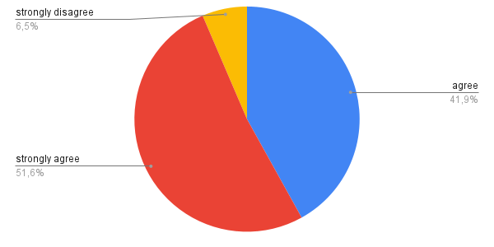
Graph 4.1 Learning to reading using spelling bee games is more interesting
Graph 1 showed that 51.6% of the selected students strongly agreed, 41.9% agreed, and 6.5% strongly disagreed. This meant that learning using spelling bee games could effectively improve students' reading skills. So, the researcher suggested teachers apply the method of using spelling bee games to help improve students' reading skills, becoming an effective method used in learning for students.
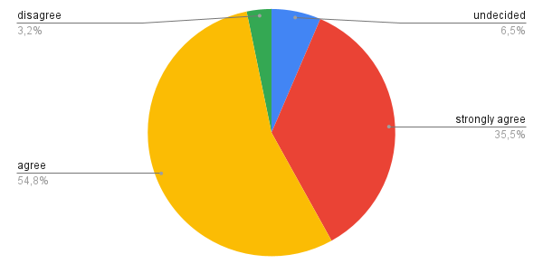
Graph 4.2 Spelling bee games be an effective tool for overcoming difficulties
Graph 2 showed that 35.5% of the selected students strongly agreed, 54% agreed, 6.5% were undecided, and 3.2% disagreed. This meant that some students were interested in English through spelling bee games, becoming an effective tool to overcome difficulties. However, some students did not agree and remained undecided.

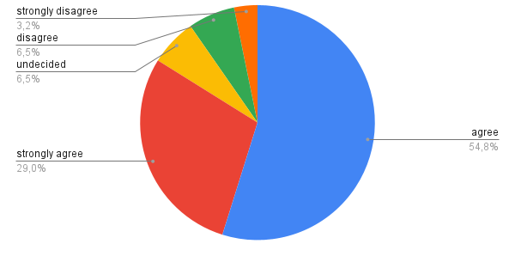
Graph 4.3 Spelling bee games is effective to increase self confidance in reading skills.
Graph 3 showed that 29% of the selected students strongly agreed, 54.8% agreed, 6.5% were undecided, 6.5% disagreed, and 3.2% strongly disagreed. This meant that most students agreed that spelling bee games were effective in increasing confidence in reading skills. However, there were also students who were still undecided and strongly disagreed.

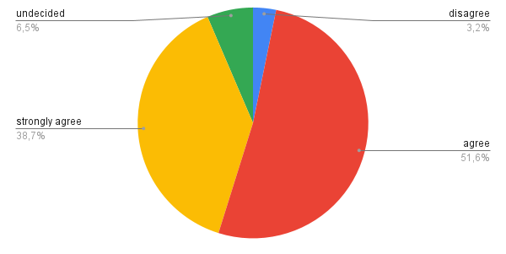
Graph 4.4 Spelling bee games help overcome difficulties in spelling bee
Graph 4 showed that 38.7% of the selected students strongly agreed, 52.6% agreed, 6.5% were undecided, and 3.2% disagreed. This meant that many students were helped to understand the difficulty of spelling using spelling bee games.

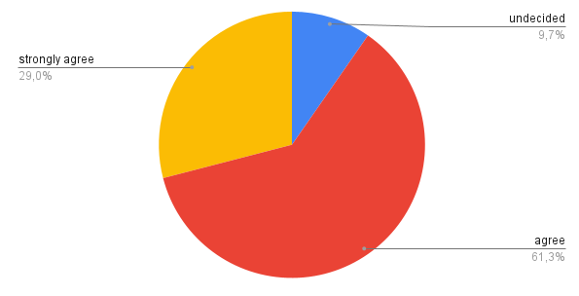
Graph 4.5 The using spelling bee games the learning process becomes more fun
Graph 5 showed that 29% of the selected students strongly agreed, 61.3% agreed, and 9.7% were undecided. This meant that many students really liked learning using spelling bee games because they found it more enjoyable. Although there were a few students who were undecided.

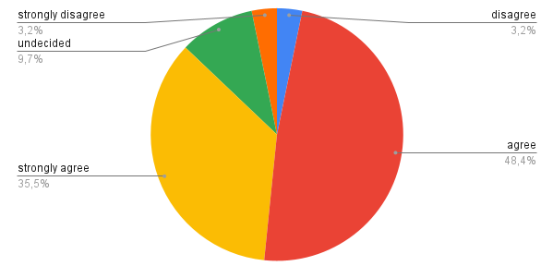
Graph 4.6 Positif impact of spelling bee games in reading interest and descreased spelling barriers
The graph showed that 35.5% of the selected students strongly agreed, 48.4% agreed, 9.7% were undecided, 4.5% disagreed, and 4.5% strongly disagreed. This meant that most students saw spelling bee activities as a positive factor that could increase their interest in reading.

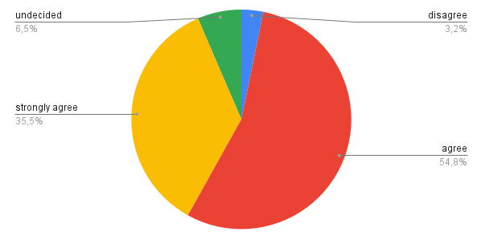
Graph 4.7 Motivation to improve reading skills throught spelling bee outside the classroom
The graph showed that 35.5% of the selected students strongly agreed, 54.8% agreed, 6.5% were undecided, and 3.2% disagreed. High scores in the "strongly agree" and "agree" categories showed that most students felt a positive boost from spelling bee activities, which encouraged them to actively improve their reading skills in an environment outside of the formal classroom context. This reflected that spelling bee had a positive impact in motivating individuals to continue developing their reading skills outside of academic settings.

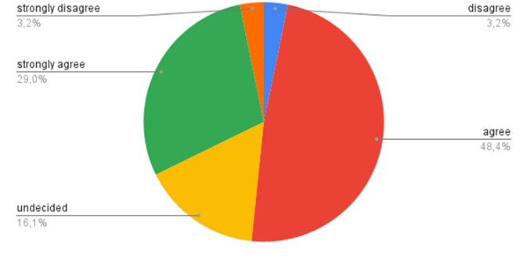
Graph 4.8 Perception of Students on the Effectiveness of Spelling Bee Games in Improving Reading Focus
Graph shows that of 29% the selected students strongly agree, 48.4% agree, 16.1% undecided, 3.2% disagree, and 3.2% strongly disagree. These results indicate that the majority of students see the spelling bee games as a positive factor that can increase focud and overcome distractions when reading.

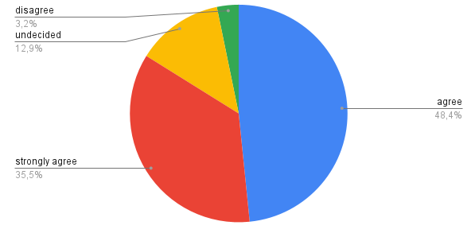
Graph 4.9 Effectiveness of spelling bee games in improving word spelling memory
The graph showed that 35.5% of the selected students strongly agreed, 48.5% agreed, 12.9% were undecided, and 3.2% disagreed. These results illustrated that the spelling bee games had an important role in strengthening the spelling memory of words, indicating that the activity was effective in facilitating the learning process and spelling recall in students.
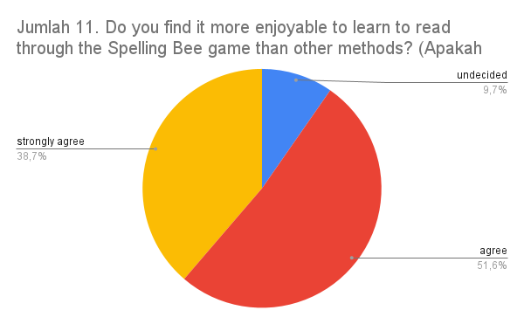
Graph 4.10 Increased interest in reading throught playing spelling bee games
The graph showed that 41.9% of the selected students strongly agreed, 35.5% agreed, and 22.6% were undecided. This meant that these results reflected that spelling bee was not only a game but also played a role in encouraging interest in reading.
Graph 4.11 Sucsess of the spelling bee games learning method in increasing the enjoyment of learning to read
The graph showed that 38.7% of the selected students strongly agreed, 51.6% agreed, and 9.7% were undecided. This meant that these results reflected the effectiveness of spelling bee games as a learning method that inspired interest and enjoyment in learning to read in its students.

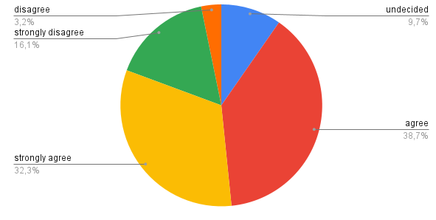
Graph 4.12 The influenceb of spelling bee in enriching everyday language
The graph showed that 32.3% of the selected students strongly agreed, 38.7% agreed, 9.7% were undecided, 3.2% disagreed, and 16.1% strongly disagreed. This meant that these results showed that the spelling bee had a positive impact inenriching vocabulary and encouraging the use of these words in daily conversation situations.

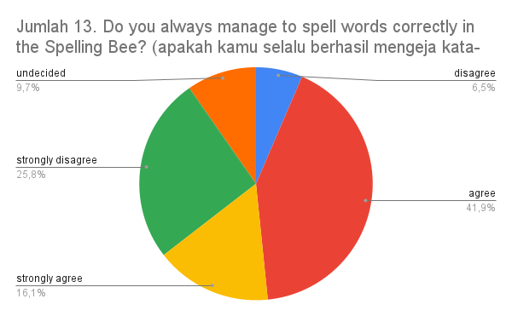
Graph 4.13 Spelling success in the spelling bee games
The graph showed that 16.1% of the selected students strongly agreed, 41.9% agreed, 9.7% were undecided, 6.5% disagreed, and 25.8% strongly disagreed. This meant that these results indicated that the majority of spelling bee students experienced a significant level of success in their ability to spell words.

- DISCUSSION
The effectiveness of Spelling Bee Game to improve reading skill at 9th grade students
Students' ability to read showed improvement based on my research. The study indicated that there was progress in students' reading abilities after the implementation of spelling bee games. However, by the end of the sessions, these students had gained understanding, recognizing that the spelling bee games played a crucial role in enhancing their reading skills. The students expressed motivation to delve deeper into reading various stories in English. This aligns with Smith's (2019) theory that learning occurs through students constructing knowledge on their own. Spelling bee games were interpreted as tools that actively involved students in learning, enhancing their understanding of words and reading.
The obstacles in using Spelling Bee Games to improve reading skill at 9th grade students
It was highlighted that each individual had a different learning style, and some students did not feel engaged or motivated by such a gaming approach.

CONCLUSION
The results that were analyzed can be concluded from the results of interviews, showing that the use of spelling bee games effectively made a positive contribution in increasing students' involvement and enjoyment in learning to read. Most students stated that the game helped improve their spelling skills, enjoyed the learning process, and made them more interested in difficult words. And the results of the questionnaire that was successfully researched regarding obstacles to using spelling bee games to improve reading skills, it could be concluded that some students experienced certain challenges. Awareness of these obstacles helped in designing strategies that were more inclusive and supported all students in improving their reading abilities.

REFERENCES
Brown, A., & Davies, F. (2015).Using game-based learning to teach reading comprehension strategies. TD: The Journal for Transdisciplinary Research in Southern Africa, 11(3), 236-249.
Davis, E., & Smith, J. (2019).Individualized Instruction and Assessment Through Spelling Bees. The Quarterly Journal of Experimental Psychology, 72(3), 599-608.
Hamilton, L., & Stevens, R. (2018).Using spelling contests to motivate and engage young learners.Primary English Teaching Association Australia, 53(4), 11-15.
Johnson, D., & Brown, K. (2019).Integrating spelling bee games in early reading instruction.Reading Improvement, 56(1), 11-20.
Miles &Huberman (2019).Qualitative Data Analysis: A Methods Sourcebook.
Roberts, M., & Johnson, L. (2017).Enhancing reading skills through spelling bee games for students with learning disabilities. Journal of Learning Disabilities, 50(2), 160-170.
Smith, C. (2018). Motivating students through spelling bee games.Journal of Reading Education, 43(2), 24-29.
Smith, J. (2019). “Enhancing Reading Skills Through Spelling Bee Games: A Constructivist Approach.” Journal of Educational Psychology, 45(2), 210-225.
Thompson, R., & Robinson, J. (2016).Improving reading fluency through spelling bee games. The Elementary School Journal, 117(3), 423-439.
Williams, S. (2017). Building vocabulary through spelling bee games. Journal of Reading, 40(1), 23-29.
Yunus, M. (2022). The use of Questioning Technique to Improve Students’ Reading Comprehension at The Ninth Grade students of SMP LPP YW UMI Makassar. The 4th Internasional Conference on Halal policy Culture And Sustainability Issues IC-HalalUMI.

